**Introduction to HTML and CSS** **- HTML Lab**

Problems for exercises and homework for the ["HTML and CSS" course @ SoftUni](https://softuni.bg/courses/html-and-css).

# Topics Covered

* **What is HTML?**
* **HTML Syntax**
* **Tags:**
  + **html, head, title, meta, body,**
  + **h1, h2, h3, h4, h5, h6, p, a, strong, em, ul, ol, li, dl, dt, dd, img, blockquote**
  + **main, aside, article, section, header, footer**
  + **details, summary, figure, caption**

# Resources

* **HTML Element references on MDN:**
  + <https://developer.mozilla.org/en-US/docs/Web/HTML/Element>
* **HTML Basics**
  + <https://developer.mozilla.org/en-US/docs/Learn/Getting_started_with_the_web/HTML_basics>
* **Semantics:**
  + <https://developer.mozilla.org/en-US/docs/Glossary/Semantics>
* **W3 Validator:**
  + <https://validator.w3.org>

# Tasks

## Simple HTML Document

Create an HTML Document and follow the requirements listed below to complete the task.

Картина, която съдържа текст, екранна снимка, Шрифт, документ

Описанието е генерирано автоматично

### Requirements

* Use the copy provided in the text file.
* Create an HTML Document with **html**, **head**, **title**, **body**.
* Don't forget the Doctype declaration.
* Body needs to contain at **6 title** – **h1**, **h2**, **h3**, **h4**, **h5**, **h6**.
* Body needs to contain at least **12 paragraphs**.
* Place **2 paragraphs** after each title.
* Make sure your html document is valid by checking in the Markup Validation Service.

### Resources

* <https://developer.mozilla.org/en-US/docs/Glossary/Doctype>
* <https://developer.mozilla.org/en-US/docs/Web/HTML/Element/html>
* <https://developer.mozilla.org/en-US/docs/Web/HTML/Element/head>
* <https://developer.mozilla.org/en-US/docs/Web/HTML/Element/title>
* <https://developer.mozilla.org/en-US/docs/Web/HTML/Element/body>
* <https://developer.mozilla.org/en-US/docs/Web/HTML/Element/Heading_Elements>
* <https://developer.mozilla.org/en-US/docs/Web/HTML/Element/p>

## Ordered & Unordered Lists

Create an HTML Document and follow the requirements listed below to complete the task.

Картина, която съдържа екранна снимка, бял, дизайн

Описанието е генерирано автоматично

### Requirements

* Use the copy provided in the text file.
* Body needs to contain **1 ul** elements with **4 li** elements each.
* Body needs to contain **1 ol** element with **6 li** elements each.
* Ensure your HTML code is valid and follows best practices. You can use the W3C Validator for checking.

### Resources

* <https://developer.mozilla.org/en-US/docs/Web/HTML/Element/ul>
* <https://developer.mozilla.org/en-US/docs/Web/HTML/Element/ol>
* <https://developer.mozilla.org/en-US/docs/Web/HTML/Element/li>

## Nested Ordered & Unordered Lists

Create an HTML Document and follow the requirements listed below to complete the task.

Картина, която съдържа текст, екранна снимка, Шрифт

Описанието е генерирано автоматично

### Requirements

* Use the copy provided in the text file.
* Body needs to contain **3 ul** elements with **4 li** elements each.
* **ul** elements should be nested in each other.
* The **second** **li** elements of the **first-level** **ol** should contain a **ol**.
* The **third** **li** elements of the **second-level ol** should contain a **ol**.
* Ensure your HTML code is valid and follows best practices. You can use the W3C Validator for checking.

### Resources

* <https://developer.mozilla.org/en-US/docs/Web/HTML/Element/ul>
* <https://developer.mozilla.org/en-US/docs/Web/HTML/Element/ol>
* <https://developer.mozilla.org/en-US/docs/Web/HTML/Element/li>

## Definition List

Create an HTML Document and follow the requirements listed below to complete the task.

Картина, която съдържа текст, екранна снимка, Шрифт

Описанието е генерирано автоматично

### Requirements

* Use the copy provided in the text file.
* Body needs to contain **1** **dl** element, **3** **dt** elements and **3** **dd** elements.
* **dt** and **dd** elements should be inside the **dl** element.
* **dd** elements should follow a **dl** element.
* Ensure your HTML code is valid and follows best practices. You can use the W3C Validator for checking.

### Resources

* <https://developer.mozilla.org/en-US/docs/Web/HTML/Element/dl>
* <https://developer.mozilla.org/en-US/docs/Web/HTML/Element/dt>
* <https://developer.mozilla.org/en-US/docs/Web/HTML/Element/dd>

## Marking Text – Links, Strong, Emphasis and more

Create an HTML Document and follow the requirements listed below to complete the task.

Картина, която съдържа текст, екранна снимка, Шрифт, документ

Описанието е генерирано автоматично

### Requirements

* Use the copy provided in the file.
* Body element must contain **5** 
  + **a** elements,
  + **2 strong** elements,
  + **2 em** elements,
  + **1 cite** element,
  + **1 sum** element and
  + **1 abbr** element.
* Ensure your HTML code is valid and follows best practices. You can use the W3C Validator for checking.

### Resources

* <https://developer.mozilla.org/en-US/docs/Web/HTML/Element/a>
* <https://developer.mozilla.org/en-US/docs/Web/HTML/Element/strong>
* <https://developer.mozilla.org/en-US/docs/Web/HTML/Element/em>
* <https://developer.mozilla.org/en-US/docs/Web/HTML/Element/cite>
* <https://developer.mozilla.org/en-US/docs/Web/HTML/Element/sup>
* <https://developer.mozilla.org/en-US/docs/Web/HTML/Element/sub>
* <https://developer.mozilla.org/en-US/docs/Web/HTML/Element/abbr>

## Images

Create an HTML Document and follow the requirements listed below to complete the task.

Картина, която съдържа текст, екранна снимка, колаж

Описанието е генерирано автоматично

### Requirements

1. **File Setup**:
   * Create an **HTML** document named **images.html**
   * Create a **CSS** file named **images.css**
2. **HTML Requirements**
   * Use **img** tag and get different images from **unsplash.com**

* Make sure you add one **ul** with **li** items and images inside

### Resources

* <https://developer.mozilla.org/en-US/docs/Web/HTML/Element/img>

## Semantic Tags – Header, Main, Footer

Create an HTML Document and follow the requirements listed below to complete the task.

Картина, която съдържа текст, екранна снимка, бял, дизайн

Описанието е генерирано автоматично

### Requirements

1. **File Setup**:
   * Create an **HTML** document named **semantic-tags.html**
   * Create a **CSS** file named **semantic-tags.css**
2. **HTML Requirements**
   * Create the simple document structure using the following tags:
     + **header**
     + **main**

### footerResources

* <https://developer.mozilla.org/en-US/docs/Web/HTML/Element/header>
* <https://developer.mozilla.org/en-US/docs/Web/HTML/Element/footer>
* <https://developer.mozilla.org/en-US/docs/Web/HTML/Element/main>

## Semantic Tags – Article, Section

Create an HTML Document and follow the requirements listed below to complete the task.

Картина, която съдържа текст, екранна снимка, алгебра

Описанието е генерирано автоматично

### Requirements

1. **File Setup**:
   * Create an **HTML** document named **semantic-tags-part2.html**
   * Create a **CSS** file named **semantic-tags-part2.css**
2. **HTML Requirements**
   * Create the simple document structure using the following tags:
     + **article**
     + **section**

### Resources

* <https://developer.mozilla.org/en-US/docs/Web/HTML/Element/article>
* <https://developer.mozilla.org/en-US/docs/Web/HTML/Element/section>

## Semantic Tags – Details, Summary

Create an HTML Document and follow the requirements listed below to complete the task.

Картина, която съдържа бял, екранна снимка, дизайн

Описанието е генерирано автоматично

### Requirements

1. **File Setup**:
   * Create an **HTML** document named **semantic-tags-part3.html**
   * Create a **CSS** file named **semantic-tags-part3.css**
2. **HTML Requirements**
   * Create the simple document structure using the following tags:
     + **details**
     + **summary**

### Resources

* <https://developer.mozilla.org/en-US/docs/Web/HTML/Element/details>
* <https://developer.mozilla.org/en-US/docs/Web/HTML/Element/summary>

## Semantic Tags – Figure, Figcaption

Create an HTML Document and follow the requirements listed below to complete the task.Картина, която съдържа домашна котка, бозайник, Малки и средни по размер котки, котка

Описанието е генерирано автоматично

### Requirements

1. **File Setup**:
   * Create an **HTML** document named **semantic-tags-part4.html**
   * Create a **CSS** file named **semantic-tags-part4.css**
2. **HTML Requirements**
   * Create the simple document structure using the following tags:
     + **figure**
     + **figcaption**

### Resources

* <https://developer.mozilla.org/en-US/docs/Web/HTML/Element/figure>
* <https://developer.mozilla.org/en-US/docs/Web/HTML/Element/figcaption>

## Semantic Tags – Nav

Create an HTML Document and follow the requirements listed below to complete the task.

Картина, която съдържа екранна снимка, бял, текст, дизайн

Описанието е генерирано автоматично

### Requirements

1. **File Setup**:
   * Create an **HTML** document named **semantic-tags-nav.html**
   * Create a **CSS** file named **semantic-tags-nav.css**
2. **HTML Requirements**
   * Create the simple document structure using the following tags:
     + **nav**

### Resources

* <https://developer.mozilla.org/en-US/docs/Web/HTML/Element/nav>

## Semantic Tags – Time

Create an HTML Document and follow the requirements listed below to complete the task.

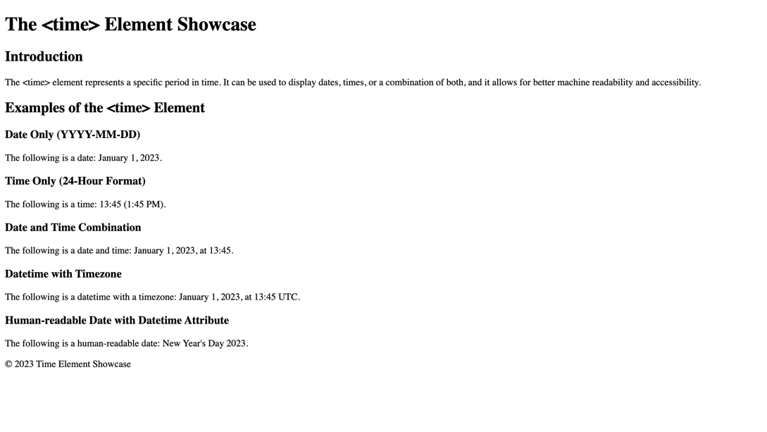

### Requirements

* **File Setup**:
  + Create an **HTML** document named **semantic-tags-time.html**
  + Create a **CSS** file named **semantic-tags-time.css**
* **HTML Requirements**
  + Create the simple document structure using the following tags:
    - **time**
* Display at least five different examples of the **<time>** element, including:
  + A date in the format "YYYY-MM-DD".
  + A time in the 24-hour format "HH:MM".
  + A date and time combination.
  + Each example should be accompanied by a brief description of what it represents, utilizing **<p>** elements for descriptions.
* Ensure your HTML code is valid and follows best practices. You can use the W3C Validator for checking.

### Resources

* <https://developer.mozilla.org/en-US/docs/Web/HTML/Element/time>

## Semantic Tags – Blockquote

Create an HTML Document and follow the requirements listed below to complete the task.

Картина, която съдържа текст, екранна снимка, Шрифт

Описанието е генерирано автоматично

### Requirements

* **File Setup**:
  + Create an **HTML** document named **semantic-tags-****blockquote.html**
  + Create a **CSS** file named **semantic-tags-blockquote.css**
* **HTML Requirements**
  + Create the simple document structure using the following tags:
    - **blockquote**

### Resources

* <https://developer.mozilla.org/en-US/docs/Web/HTML/Element/blockquote>

## Wiki Article

Create an HTML Document and follow the requirements listed below to complete the task.

Картина, която съдържа текст, екранна снимка, Шрифт, документ

Описанието е генерирано автоматично

### Requirements

* **File Setup**:
  + Create an **HTML** document named **wiki-article.html**
  + Create a **CSS** file named **wiki-article.css**
* **HTML Requirements**
  + Create the simple document structure using the following tags:
    - **Article**
  + Use the **<article>** tag to define the main content of your article.
  + Break your article into sections using the **<section>** tag, each with a relevant heading (**<h1>** through **<h6>**).
  + Ensure the main heading of your article is within an **<h1>** tag, placed inside the **<article>** tag.
  + Use **<p>** tags for paragraphs.

### Resources

* <https://developer.mozilla.org/en-US/docs/Web/HTML/Element/article>
* <https://developer.mozilla.org/en-US/docs/Web/HTML/Element/header>
* <https://developer.mozilla.org/en-US/docs/Web/HTML/Element/time>
* <https://developer.mozilla.org/en-US/docs/Web/HTML/Element/section>
* <https://developer.mozilla.org/en-US/docs/Web/HTML/Element/p>
* <https://developer.mozilla.org/en-US/docs/Web/HTML/Element/Heading_Elements>